AMRIT KALASH MAHILA FARMER PRODUCER COMPANY LIMITED, BLOCK-BADWARA,DIST-KATNI (M.P.)

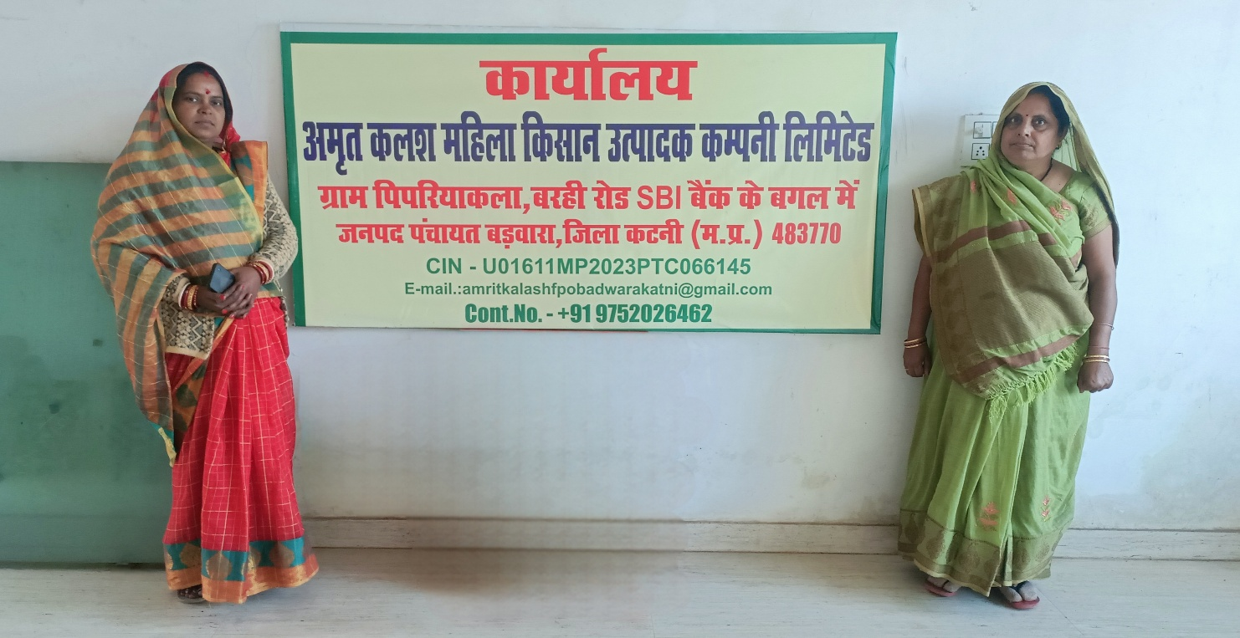

**Detail Project Report**

DPR

MPSRLM KATNI BADWARA

Table of Content

# Executive Summary, Background, Block and district Profile

1. General Information of the block and project cluster.
2. Economics of Agriculture – Cropping Pattern. Costing, input, and output ratios, yields and current productivity
3. Production Practices
4. Financial Aspects – Sources, terms and conditions, interest and existing outstanding, access to government programs
5. Risk Aspects – Historical risks, computation of losses due to risk, coping mechanisms
6. Marketing Aspects – Channels of marketing, margins and costs at various levels, quality aspects, price sensitivity, seasonality of markets, alternate market structure, present and future demand of product.
7. Best Practices
8. Constraints and Challenges (SWOT)
9. Scope for Interventions along with Convergence.
10. Scope of convergence
11. Conclusion
12. Photographs of meetings held with details
13. Annexures

# 1. Executive Summary, Background and Block Profile

## **1.1 Executive Summary**

(It includes all the details which will become part of a detailed project report including project phasing and timelines, project financial viability and sustainability including - detailed business plan, with investment and operating cost estimates but in summary form)

**1.2 Background**

The FPO intervention can help small and marginal farmers to cater some of their difficulties by making collective efforts. Thus the Department of Agriculture, Cooperation and Farmers’ Welfare, Ministry of Agriculture and Farmers’ Welfare Govt. of India has launched a Central Sector Scheme for Promotion and formation of 10,000 Farmer Producer Organizations Throughout the Country which is being implemented through various stakeholders such as Implementing Agencies, Cluster- Based Business Organizations (CBBOs), National Project Management Agency (NPMA) and concerned State Authorities

The concept of collective strength is not new. Cooperatives are working traditionally for the farmers benefit and Agri development by supplying credit and other services. But most of these institutions are weakened due to poor financial resources and lack of professional management. This resulted to defunct institutions. Hence the context of collective efforts needs to re look in terms of extent of work, ownership and participation of farmers in the process.

In agriculture and Agri – allied sector most of the collectives have disproportionately focused on the production side, while providing very little attention to processing, value addition and market linkages. Hence it requires farmer-controlled institutions to engage in a more holistic and end-to-end approach in addressing the issues faced by the small farmer. Traditional cooperative societies were developed based on single activity; however, with changing scenario, holistic value chain approach is required to develop sustainable collective Institution. Proposed Farmer Producer Organizations (FPO), therefore, consider interventions starting from procurement/Initial services to production and processing to marketing in collective form.

Implementing Agencies are supporting this intervention by setting up Cluster- Based Business Organizations (CBBOs) at the State / Cluster level to form and promote FPOs as per their requirements. CBBOs are entrusted to assist in the implementation of the program as per scheme guidelines and as may be suggested by the NPMA. The CBBOs are entrusted to carry out baseline survey, cluster finalization, value chain study, formation of groups and FPOs and assist in their periodical meetings, registration of FPOs, training and capacity-building, linking these bodies to input suppliers, technology providers and market players.

The CBBOs will help FPOs in preparation and execution of business plan for long term sustainability, assist in regular interface with various stakeholders like Govt. Agencies, Financial Institutions, Training and Research and development Institutions at the cluster level and facilitate them to avail the Equity grant and credit guarantee facility as per their needs for creation of necessary common pool production, marketing and processing infrastructure. Will also assist FPOs in communication dissemination to farmers by way of market and crop advisory, periodical submission of progress reports to NPMA, adherence to all legal and statutory compliances, MIS Reports generation, proper financial management and utilization of funds and over all monitoring of the various activities crucial for long term sustainability.

To mainstream the process of institutional development of Farmer Producer Organizations, DAC & FW has issued the operational guidelines to encourage and support FPO promotion as a regular activity and the selected CBBO (MP-DAY SRLM) has prepared this Detailed project report on the basis of these guidelines to promote a farmer Producer Organization (FPO) under the Central Sector scheme for formation and promotion of 10,000 FPOs in Badwara Block of Katni District of (Madhya Pradesh).

**Project Site**

MPDAYSRLM PIPARIYA KALAN BLOCK BADWARA,DISTT KATNI,MADHYA PRADESH,INDIA,483770

**1.3 Block and District Profile**

#### Katni district of Madhya Pradesh State has an area of 4949.5 square kilometers.

#### Katni district is located around 399 Km from the State Headquarters. Katni district had population of 1292042 of which male and female were 662013 and 6300289 respectively as per the latest Census carried out in the year 2011-23.

#### Badwara Block of Katni District in (M.P.) has an area of 487 square kilometers.

The block boundary of Badwara is located at [23.72°N 80.59°E](https://geohack.toolforge.org/geohack.php?pagename=Amarpatan&params=24.32_N_80.98_E_).

Badwara is a block in district Katni in the state of Madhya Pradesh in India. Badwara Block is located around 43 Km from the District Headquarters and around 417 km from State capital. Badwara Block had population of 104166 which male and female were - 55783 and 48383 respectively as per the latest Census carried out in the year 2011 .

Area, Production and Productivity of major TOP 8 Agricultural and Horticultural Crops of the Block of last year:

|  |  |  |  |
| --- | --- | --- | --- |
| **S.No.** | **Agri. Commodity** | **Production (in MT)** | **Productivity (MT/HA)** |
| 1  2 | Paddy  Wheat | 67236.40  61723.20 | 4.366  3.507 |
| 3 | Gram | 1840.08 | 0.697 |
| 4 | Mustard | 661.65 | 1.203 |
| 5 | Moong | 257.40 | 0.584 |
| 6 | Urd | 489.42 | 0.742 |
| 7 | Maize | 5060.24 | 2.706 |
| 8 | Lentil | 99.4 | 0.904 |

|  |  |  |
| --- | --- | --- |
| **S.No.** | **Horti. Commodity** | **Production (in MT)** |
| 1 | Potato | 30043.2 |
| 2 | Tomato | 5280 |
| 3 | Onion | 6336 |
| 4 | Chilli | 59.69 |
| 5 | Cauliflower | 70.45 |
| 6 |  |  |
| 7 |  |  |
| 8 |  |  |

**General Information of the block and project cluster.**

#### (Demographics, household size, members, and details of occupation)

|  |  |  |
| --- | --- | --- |
| S. No | Parameter | Badwara Block |
|
| 1 | Total No of Villages. | 151 |
| 2 | Total Population of the Block | 104166 |
| 3 | No. of Male | 55783 |
| 4 | No. of Female | 48383 |
| 5 | Working population in agriculture | 8634 |
| 6 | Total House Holds | 23463 |
| 7 | SC House Holds | 2346 |
| 8 | ST House Holds | 3519 |
| 9 | Avg. members per Household | 5 |

#### 2.1 Education Status:

|  |  |  |  |  |
| --- | --- | --- | --- | --- |
| S. No | Parameter | Badwara Block | Badwara Project Cluster | |
| Male(nos.) | Female(nos.) |
| 1 | Total Population | 104166 | 55783 | 48383 |
| 2 | Illiterate | 27666 | 7894 | 19772 |
| 3 | Literate | 76500 | 47889 | 28611 |
| 6 | Primary | 12345 | - | - |
| 7 | Matriculation/  Secondary | 17550 | - | - |
| 8 | Higher Sec/ Sr. Sec./Intermediate | 21463 | - | - |
| 9 | Graduate degree and above | 25142 | - | - |

## **2.2 Occupational Details:**

|  |  |  |  |  |
| --- | --- | --- | --- | --- |
| S. No. | Parameter | Badwara Block | Badwara Project Cluster | |
| Male (nos.) | Female (nos.) |
| 1 | Total Population | 47597 | 28440 | 19157 |
| 2 | Agriculture / Horticulture as a major activity | 8634 | 6708 | 1926 |
| 3 | Non-farm activities (shop owners, non-farm labor etc.) | 17596 | 12204 | 5392 |
| 4. | Salaried jobs | 6345 | 4514 | 1831 |
| 5. | Livestock rearing as a major activity | 1546 |  |  |

#### 2.3 Socio-economic Profile:

|  |  |  |
| --- | --- | --- |
| S No | Particulars | Badwara Block |
| 1 | Geographical Area (sq km) | 487 |
| 2 | Population (total) | 104166 |
| 3 | Males | 55783 |
| 4 | Females | 48383 |
| 5 | Population (rural) | 104166 |
| 6 | % rural population | 100% |
| 7 | %. of Households BPL | 46% |
| 8 | % of Households APL | 54% |
| 9 | Average Landholding size (in ha) | 2-3 |

**2.4 Land use Patterns (Acres / Ha)**

|  |  |  |
| --- | --- | --- |
| S No | Parameters | Badwara Block |
| 1 | Total Geographical Area | 487Sq.Km. |
| 2 | Total Cultivable Area | 22000 |
| 3 | Net Sown Area | 21350 |
| 4 | Gross Cropped Area | 53375 |
| 5 | Forest Area | 21954 |
| 6 | Fallow Land | 8800 |
| 7 | Rain fed area | 4000 |
| 8 | Canal irrigated area | 500 |
| 9 | Tube Well irrigated area | 500 |

**2.5 Land holding:**

In the rural areas, agriculture is the mainstay of the economy, with hardly any non-farm occupations available. Land Holding Pattern of the Badwara Block and Pipariya kala Badwara project cluster is as under.

|  |  |  |  |  |
| --- | --- | --- | --- | --- |
| Location | Total Farmers (Nos.) | Small  Farmers  No. | Medium Farmers  No. | Large Farmers  No. |
| Badwara Block | 42450 | 23377 | 18566 | 507 |
| Pipariya kala,Badwara project | 42450 | 23377 | 18566 | 507 |

For the census, the government classifies land holdings into five groups: marginal (with holdings of less than one hectare), small (1-2 hectares), semi-medium (2-4 hectares), medium (4-10 hectares), and large holdings of over 10 hectares.

It is clear from the above table that Medium and small farmers predominate in the villages of Badwara Block and Pipariya Kala Badwara project clusters having maximum number of Medium and small farmers together comprise 98.59 percent of the total.

**2.6 Mode of transportation**.

|  |  |  |
| --- | --- | --- |
| Mode of transportation | Badwara Block | Pipariya Kala Badwara Project Cluster |
| Train service | Yes | Yes |
| Bus service | Yes | Yes |
| Truck service | Yes | Yes |
| Estimated no. of Tractor available | 1500 | 1500 |
| Others like tempo service etc. | >Yes | >Yes |

#### 3.0 Economics of Agriculture – Cropping Pattern, costing, input and output ratios, yields and current productivity

#### Crop wise cost of Production, Productivity per Acre / Ha, Average Realization from sale of commodities grown to be captured for top 5 Agricultural / Horticultural Crops grown in the Badwara block and Pipariya Kala Badwara project Cluster.

|  |  |  |  |  |  |  |  |  |
| --- | --- | --- | --- | --- | --- | --- | --- | --- |
| S.No. | Season | Crop | Sowing Time | Harvesting Time | Production on Cost (INR/MT) | Max.Selling Price | Average Selling price | Productivity Q/Ha |
| 1 | Kharif | Paddy,Moong,Urd | July-AugApril-MayApril-May | Oct-NovOct-NovOct-Nov | 97562484327455 | 218307755069500 | 205007625068500 | 43.665.857.42 |
| 2 | Rabi | MustardGramWheat | Oct-NovOct-NovNov-Dec | March-AprilMarch-AprilApril-May | 265532122113954 | 545005335021250 | 53750 | 12.036.9735.07 |

#### 4. Production Practices –

#### 4.1 Availability of Basic amenities: Electricity, Internet and Water

#### Availability of Electricity, Water facility, Internet forms the gamut of basic amenities for the household and defines the socio-economic condition of the household in the block& project clusters. Hence data pertaining to these facilities may be captured here.

|  |  |  |
| --- | --- | --- |
| S No | Parameter | Badwara Block |
|  |
| 1 | Total no. of House Holds (HH) | 23463 |
| 2 | No. of HH Having Electricity connection | 23240 |
| 3 | No. of HH having Potable water Availability | 10246 |
| 5 | Average Availability of Electricity (Hrs./day) | 17 |
| 6 | Availability of Internet in the block  Good/Moderate/Poor | Moderate |

#### Type of potable water facilities available in the block may be explained i.e. piped supply through overhead tanks, direct supply from tube wells, Supply from water treatment plants, Hand Pumps, Submersible pumps etc.

#### 4.2 Climate and Soil:

The climate of Block Badwara Katni district M.P. characterized by a summer and general dryness except during the south west monsoon season. The year may divided into four seasons. The cold season, December to February is followed by the hot season from March to about middle of June. The period from the middle of June to September is the south west monsoon season. October and November form the post monsoon or transition period.

The nearest Observatory is Jabalpur. The climatological parameters of Jabalpur is used for analysis of rainfall. The average annual rainfall of Block Badwara,Katni is 1171.4 mm. Block Badwara,Katni received maximum rainfall during south west monsoon period i.e. June to September about 56.9% of the annual rainfall received during monsoon season. Only 13.1% of the annual rainfall takes place between October to May period. Thus surplus water for ground water recharge is available only during the south west monsoon period.

The normal maximum temperature received during the month of May is 42.00c and minimum during the month of Dec./January is 90C. The normal annual means maximum and minimum temperature of Block Badwara Katni is 320C & 180C respectively. During the south west monsoon season the relative humidity generally exceeds 88% (August month). In the rest of the year is driver. The driver part of the year is the summer season, when relative humidity’s are less 31% May is the driest month of the year.

The wind velocity is higher during the pre-monsoon period as compared to post monsoon period. The maximum wind velocity 8.2 km/hr observed during the month of June and minimum 2.6 km/hr during the month of December. The average normal annual wind velocity of Block Badwara,Katni is 4.9 km/hr. Normal climatologically parameter of Block Badwara,Katni is given in attached annexure.

#### 4.3 Soil Types

Soil of the Block Badwara,Katni may be classified according to their physical property, the crops grown and their position. The low lying area is occupied by pale yellow, reddish brown & block soil.

Pale yellow is occupying alluvium, reddish brown is occupying the upper Bhander sands tones & black soil is occupying the argillaceous sirbushaler. All the agricultures fields are located over shales are covered by medium block soil & it occuping the argillaceous. Sirbu shale All the agriculture field are located over shales are covered by medium black soil it varies in the thickness from place to place from 1 to 4 m.

**4.4 Availability of inputs:**

Agri inputs are available in suficient amount and with good and moderate qualityvarious Agri-inputs such as Fertilizers, Manure, Pesticides, Herbicides, High quality Seeds, seedlings etc. required for growing the major crops

|  |  |  |
| --- | --- | --- |
| S.No. | Parameter | Nos. in block |
| 1 | Fertilizer dealers | 17 |
| 2 | Pesticide dealers | 14 |
| 3 | Seed dealers | 39 |
| 4 | Nurseries | 2 |
| 5 | Tractor Agencies | 20 |
| 6 | Agri-implements dealers | 5 |
| 7 | Agri – implement repair workshops | 20 |
| 8 | Custom Hiring Centers (Agri-implements) | 0 |

**4.5 Access to Pre and Post Harvest Facilities:**

|  |  |  |
| --- | --- | --- |
| S. No | Parameter | Nos. in block |
| 1 | Soil testing labs | 0 |
| 2 | Agri-clinics | 0 |
| 3 | Krishi Vigyan Kendra (KVK) | 0 |
| 4 | Training Center for farmers | 0 |
| 5 | Agriculture University (AU) or Nearest AU with distance | 128km(Jabalpur block,Jabalpur) |
| 6 | APMC Mandi | 0 |
| 7 | Food Parks |  |
| 8 | Agri Exports Zones | 0 |
| 9 | Mills / Processors |  |
| 10 | Packaging centers | 0 |
| 11 | Food quality testing laboratory | 0 |
| 12 | Pack houses/Primary Processing centers/Collection Centre with capacity | 0 |
| 13 | Procurement centre | 0 |

**4.6 Availability of surplus crops for sale (Top 5 Crops)**

|  |  |  |  |  |  |  |
| --- | --- | --- | --- | --- | --- | --- |
| S.no | Crop | SeasonKharif / Rabi | Harvest period | ProductionMT | Local ConsumptionMT | Free surplus for sale MT |
| 1 | Wheat | Rabi | April-May | 61723.20 | 7406.78 | 54316.42 |
| 2 | Mustard | Rabi | March-April | 661.65 | 650 | 11.65 |
| 3 | Gram | Rabi | Oct-Nov | 1840.08 | 92.00 | 1748.08 |
| 4 | Paddy | Kharif | Oct-Nov | 67236.40 | 8068.36 | 59168.04 |
| 5 | Urd | Kharif | Oct-Nov | 489.72 | 9.79 | 479.93 |

Add rows if more than 5 crops are majorly grown in the Block and or Project Cluste**r**

**5. Financial Aspects –** Sources, terms and conditions, interest and existing outstanding, access to government programmers

**5.1 Sources of Finance available to Farmers**

|  |  |  |  |  |  |
| --- | --- | --- | --- | --- | --- |
| S.No. | Source | Name of bank | No. of branches | Rate of Interest | KCC Account Holders (Nos) |
| 1 | Scheduled Commercial Banks | **CBI** | **3** | **11.5%** | **487** |
| **SBI** | **3** | **12%** | **340** |
| **MPGB**  **DIAN(Allahabad)** | **3**  **1** | **12.5%**  **11%** | **728** |
|  |  | **HDFC**  **BOI** | **1** | **11.5%**  **11%** | **1654**  **344** |
| 2 | Cooperative Banks | **-** | **-** |  |  |
|  |  |  |  |
| 3 | Micro Finance Banks | **-** | **-** | **-** | **-** |
|  |  |  |  |
| 4 | Non-Banking Finance Cos | **-** | **-** | **-** | **-** |
|  |  |  |  |
| 5 | Other Financial Institutions | **-** | **-** | **-** | **-** |
|  |  |  |  |

Other terms and conditions for extension of farm loans and difficulties faced by farmers (if any)

**5.2 Access to Government Programs (Latest cumulative figure):**

|  |  |  |  |
| --- | --- | --- | --- |
| S. No | State/Central Government Programs | Scheme Name | Number of farmers Availing Scheme |
| 1 | Central Govt. | PM Kisan | **187** |
| 2 | Central Govt. | PMFBY | **2419** |
| 3 | Central Govt. | PMFME | **12** |

1. **Risk Aspects – Historical risks, computation of losses due to risk, coping mechanisms.**

The block has suffered from different crisis including drought and flood etc, which caused a huge loss to the crops of kharif,rabi and zaid season. The greater damage was caused by Drought to the farmers and the land in the last few years.

**6.1 Historical Risks**

Last Five years data required to estimate historical risk

|  |  |  |  |  |
| --- | --- | --- | --- | --- |
| S.No. | Type of Crisis | Month and Year of Occurrence | Nos. of farmer affected | Crop involved in crisis |
| - | - | - | - | **-** |
|  |  |  |  |  |

**6.2 Coping and Mitigating mechanism:** Measures available to compensate the losses occurred like crop insurance etc.

**7. Marketing Aspects –** Channels of marketing, margins and costs at various levels, quality aspects, price sensitivity, seasonality of markets, alternate market structure, present and future demand of product.

**7.1 Channels of Marketing:**

Presence of APMC Regulated wholesale market for Agriculture and Horticulture Produce in the Block

|  |  |  |  |
| --- | --- | --- | --- |
| S.no | Name and location of APMC Market | Distance in Km from Block HQ | Major commodities handled |
| **1.** | **-** | **-** | **-** |

**7.2 Presence of weekly Haats and Garmin Bazaars in the Block if any,**

|  |  |  |  |
| --- | --- | --- | --- |
| S.no | Name and location of weekly Market | Distance in Km from Block HQ | Major commodities handled |
| **1.**  **2.**  **3.** | **Pipariyan kala**  **Barhi**  **Basadi** | **15**  **27**  **12** | **Vegetables, Cloths, beauty and kitchen ware** |

**7.3 Presence of Village level traders**

**7.4 Presence of Processing and Quality Assaying facilities in Clusters nearby**

|  |  |  |  |  |
| --- | --- | --- | --- | --- |
| S.no | Name and location of Processing Cluster | Quality Assaying Facilities | Distance in Km from Block HQ | Major commodities / Products |
| **1.** |  |  |  |  |

**7.5 Value Chain Study**

Stakeholders involved, economics at different levels of stakeholders, service providers’ profile, terms at which services are obtained, potential value chain identified, intervention required to develop value chain.

Commodities wise value chains of project clusters (different actors involved in the value chain from farmer till consumer, Cost and margins of each actor involved in value chain, Prioritization from the different commodity value chain to select prime commodity benefitting the project cluster farmers.

|  |  |  |  |  |
| --- | --- | --- | --- | --- |
| Stake holder of Value chain | Service performed | Commodity - 1 | Commodity - 2 | Commodity - 3 |
| Farmer | Production | Selling Price | Selling Price | Selling Price |
| Village level Trader | Aggregation | 1.Buying Price  2.Selling price  3.Margin | 1.Buying Price  2.Selling price  3.Margin | 1.Buying Price  2.Selling price  3.Margin |
| APMC trader | Facilitate buying and selling | 1.Buying Price  2.Selling price  3.Margin | 1.Buying Price  2.Selling price  3.Margin | 1.Buying Price  2.Selling price  3.Margin |
| Processers | Value addition | 1.Buying Price  2.Selling price  3.Margin | 1.Buying Price  2.Selling price  3.Margin | 1.Buying Price  2.Selling price  3.Margin |
| Distributors | Stockiest and distribution | 1.Buying Price  2.Selling price  3.Margin | 1.Buying Price  2.Selling price  3.Margin | 1.Buying Price  2.Selling price  3.Margin |
| Retailers | Point of sale | 1.Buying Price  2.Selling price  3.Margin | 1.Buying Price  2.Selling price  3.Margin | 1.Buying Price  2.Selling price  3.Margin |
| Targeted market (consumer etc.) | Consume commodities as per intended use | Buying Price | Buying Price | Buying Price |

Note: Stakeholder may vary geographically and commodity wise

# 7.5.1 Gaps identified in value chain study

Constraints pertaining to value chain in the block

1. Gap identified pre and post production gaps pertaining to technology (Lack of knowledge on latest technology, Artificial intelligence, Big data, Block chain, Traceability, Latest Pest Management Technology, Remote sensing etc.)
2. Institutional and market (Availability of Viable farmers institution, market intelligence, market price for the produce, Market Linkage etc.)
3. Infrastructure (Warehouse, Logistics, Storage, Farm mechanism, etc.)
4. Socio economic (Availability of farm labor, Insurance of crop, Economics of scale, Adaptation to new technologies, etc.)

e.g.:

* Distress sale due to lack of information and access to credit
* Losses observed: Limited grading facility at the farm level
* Post-harvest loses due to Lack of proper storage system
* Lack of awareness about value addition – primary processing, grading and packaging

Availability of Agri inputs like Quality seed, fertilizers, Plant Protection chemicals, Farm equipment. Access to alternate market structures such as online markets such as e-NAM, NCDEX, other commodity exchanges.

**7.5.2 Availability of storage infrastructure**

|  |  |  |  |  |
| --- | --- | --- | --- | --- |
| S.No. | Storage Structure | Nos. | Capacity MT | Rate of Storage Rs/MT/Month |
| 1. | WDRA Approved ambient temperature warehouses |  |  |  |
| 2. | Other ambient temperature warehouses |  | - |  |
| 2a | Central Warehousing Corporation | - | - | - |
| 2b | State Warehouse Corporation | - | - | - |
| 2c | Private Warehouses | 20 | 5000 | 650 |
| 3 | Cold Stores | - | - | - |
| 4 | Controlled Atmospheric Cold Stores | - | - | - |

**8. Best Practices**

Pre- and Post-harvest best practices adopted by the farmers in the block.

1. **Constraints and Challenges** (SWOT)

**a. Strengths:**

i. Good supplementary activity in the scheme area for doubling the farmers income

ii. Adequate availability of forward and backward linkages in the scheme area

**b. Weaknesses:**

i. Limited green fodder availability in the scheme area

ii. Inadequate awareness among the farmers

**c. Opportunities:**

i. Growing demand from consumers in the area due to increasing in income level

ii. Proximity to demand centres / markets

**d. Threats:**

i. Changes in Govt. policy leading to adverse procurement price

ii. Weak monsoons adversely affect the production and thereby procurement.

# 10. Scope for Interventions along with Convergence.

Possible Interventions required to eliminate the gaps identified and to develop value chain in the block. Like (illustration)

1. Training and capacity building (Topic, Target People, Validation, Plan, Reporting, PDCA (Plan, Do, Check and Act)
2. Custom Hiring Centers and input shops
3. Credit linkage
4. Seed & crop production
5. Value addition and processing
6. Market linkage and market information
7. ODOP crop of the block:

if its chosen then what are varieties available and value addition potential, harvest season etc.

If not chosen, the rationale for choosing a non ODOP crop

e.g.:

* Preproduction and Production: Supply of quality inputs, planting materials, machinery, and technology through common service centers
* Post-harvest/Storage: Availability of logistics and storage facility
* Value addition: Farmer common Service Centers along with facilities of primary processing, packaging & logistics. Establishment of secondary processing units
* Access to Govt. Schemes: Availing credit support from various central and state government schemes
* Marketing environment: linkage with corporate buyers, processors and exporters

# 11 Scope for Convergence

Several programs and schemes being offered by the Central and State Governments in order to support and strengthen the agriculture sector and FPOs like: equity grant, Credit Guarantee scheme, Pradhan Manti Kisan Sampada Yojana (PMKSY), MIDH, Scheme for Fund for Regeneration for Traditional Industries (SFURTI), etc. Identify the suitable scheme and converge for better outcome leveraging the financial outlay.

**12. Conclusion**

**Way Forward with regard to activities by the FPOs.**

Effective possible pathway to address improved access to investments, technologies, knowledge support, inputs, and markets. Benefit for farmer, community, and nation.

**13. Photographs of meetings held with details**

Purpose of meeting was to give the information about FPO and to join share holders for the FPO, place of meeting was in different villages of Block Badwara, Distt- Katni (Villages such as Khanna Banjari,Bagaiha,Santi Nagar Pipariya Kala etc), Meetings were held in the month of December-january, meeting was between Village farmers,Company CEO and BODs.

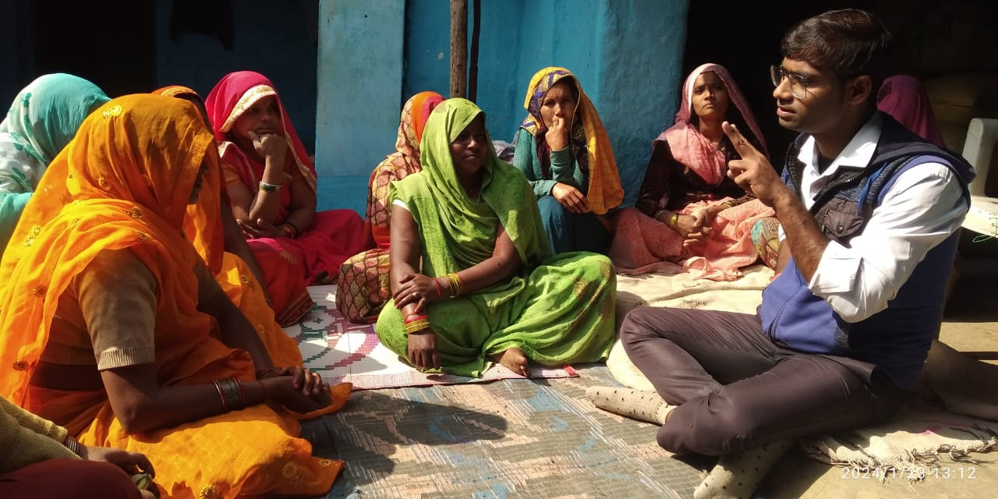

**Village-Bujbuja**

**Date-23/01/24**

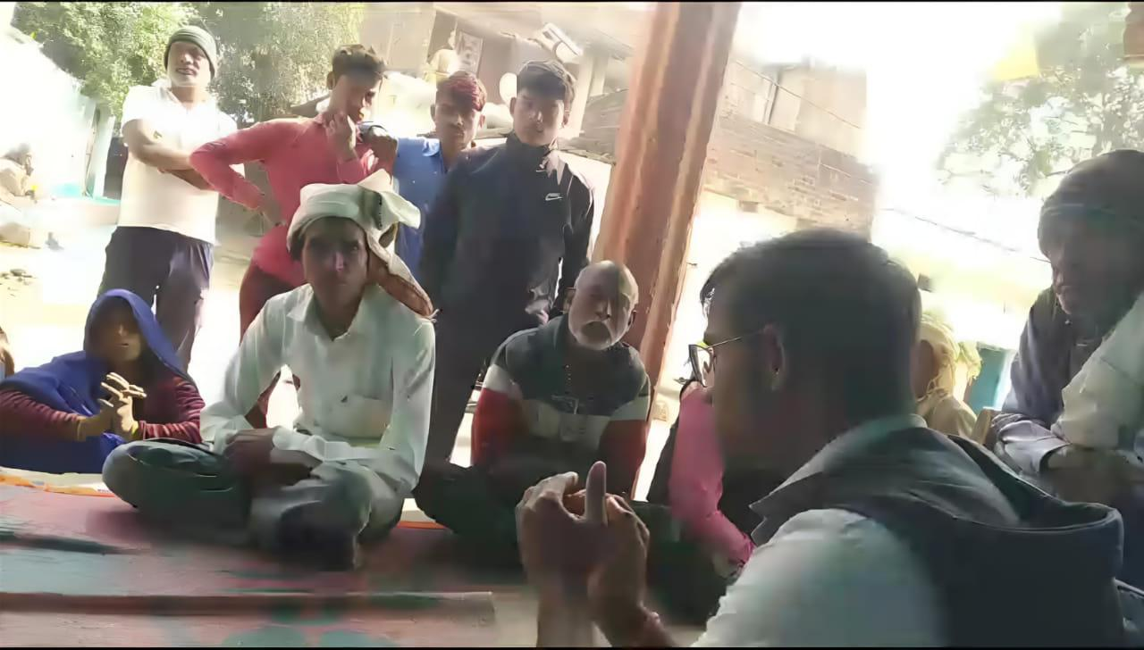

**Village-Bahirghta**

**Date-23/01/24**

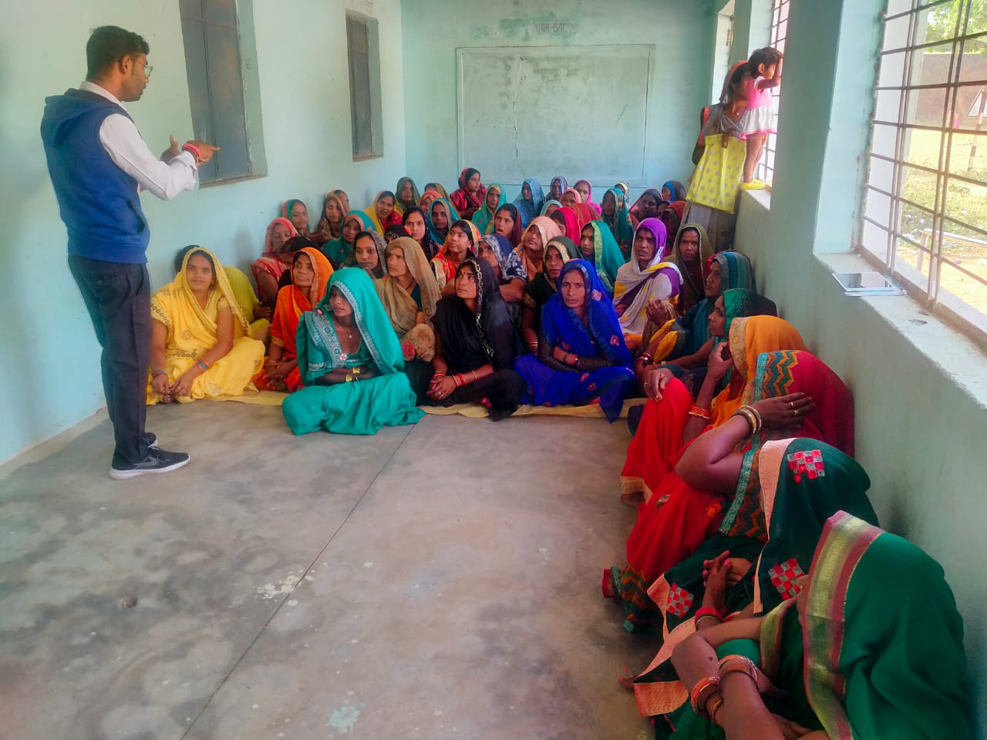

**Village-Khanna Banjari**

**Date-26/12/23**

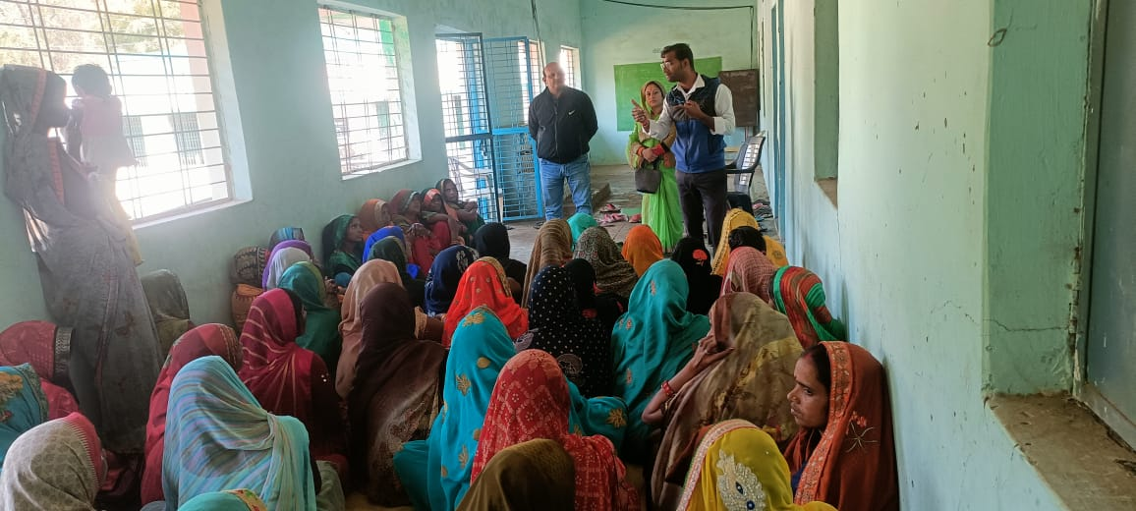

**Village-Khanna Banjari**

**Date-26/12/23**

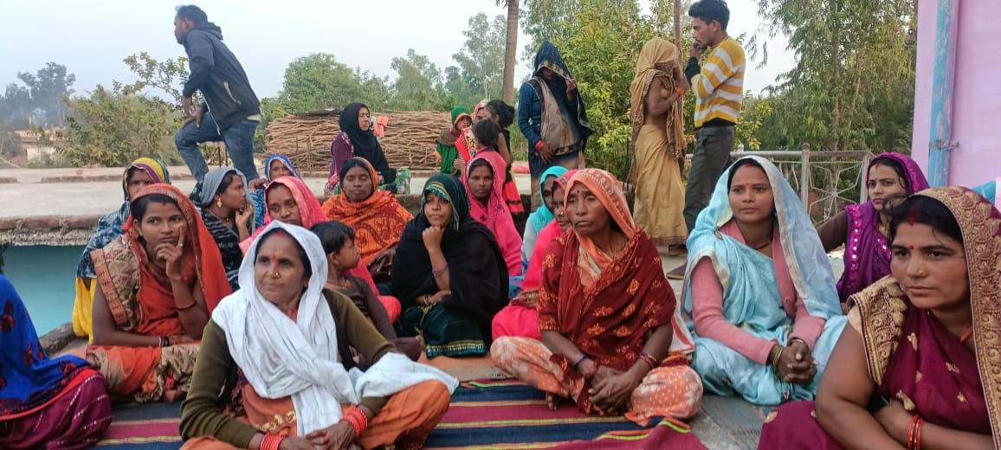

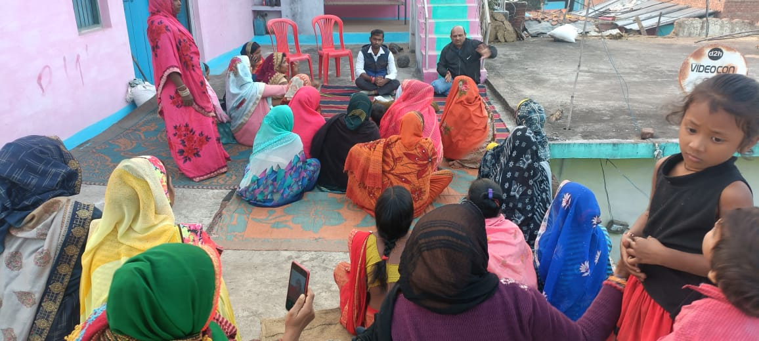

**Village-Bagaiha**

**Date-26/12/23**

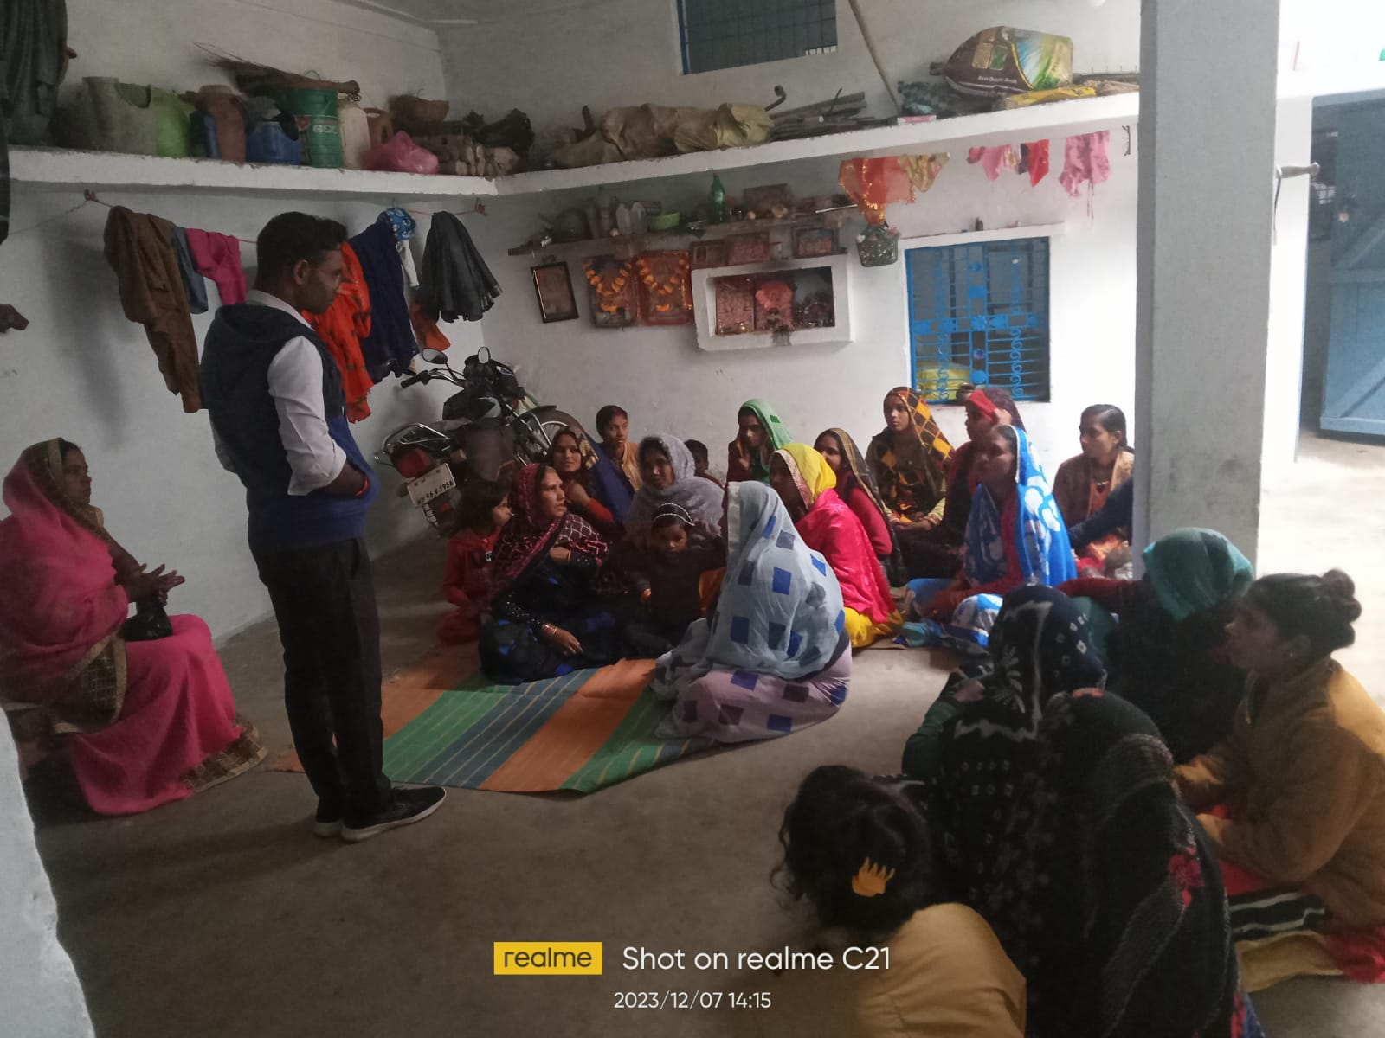

**Village-Santi Nagar ,Pipariya Kala**

**Date-07/12/23**

# 

**Village-Bangwan**

**Date-01/12/23**

# 14. Annexures

Annexure 1: Farmer stakeholders consulted

Annexure 2: Government and other stakeholders consulted

Annexure 3: Questionnaire schedule format for Baseline survey