SAFETY DEVICE

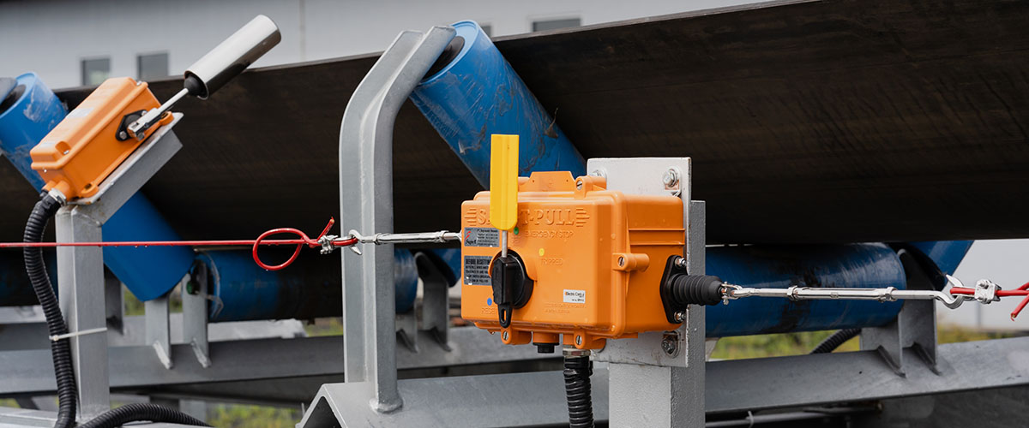

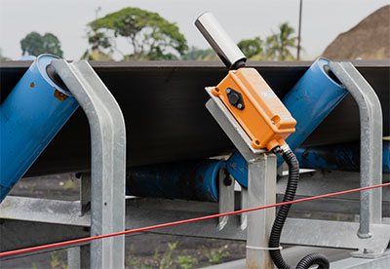

Supra is the exclusive distributor of Electric Control Product (ECP) for Indonesia market. The role of this device is very important for the safety side. It is a compact systematic design that facilitates the installation process while also providing safety protection functionality for users of rubber belts (belt conveyors). Electric Control Products always performs thorough testing of all micro-switches units both mechanically and electrically. ECP using Australian Standard AS/NZS 3947.5.5/IEC 60947.5.5

**Our featured products:**

* Pull Cord. Is an instrumentation device like an emergency stop? In contrast to the emergency stop button which is activated by pressing, the sensor of this instrument works by pulling the cable/wire as a trigger for breaking the flow of communication and electric signals. This wire is attached along the conveyor.
* Belt Sways or Misalignment Switch. Is a sensor that functions as a detector if the conveyor belt shifts to the left or right or mis-tracking. If the belt shifts and touches the lever (roller arm), the sensor which has an elevation limit of degrees will trigger a communication signal breaker and stop the rubber belt.
* Belt Rips. Is an important instrument for the smooth running during production? The function of the tool is to detect accidental tearing of the conveyor belt at an early stage caused by foreign objects tearing/penetrating the conveyor belt.

Head Office

PT. Suprabakti Mandiri  
Jl. Danau Sunter Utara Blok A No. 9 Sunter, Jakarta Utara - 14350.

* Phone : 021-658 33666
* Fax : 021-658 33666
* E-Mail [info@beltcare.com](mailto:info@beltcare.com)

Factory

PT. Suprabakti Mandiri  
Jl. Raya Pasar Kemis Km 3,5 Desa Kutajaya, Pasar Kemis, Tangerang - 15560

* Phone : 021-590 3748
* Fax : 021-590 3747