

RANOLIA ENGINEERING
(AN ISO 9001-2015 CERTIFIED COMPANY)
Spl. In : ALL KINDS OF CNC & VMC JOB WORKS

RANOLIA ENGINEERING was established in Year 1987,
By Mr. V.P. Verma having a rich experience and technical knowledge in manufacturing machined, Tool Room & fabricated components, and supported by a team of highly skilled professionals with sound knowledge and exposure has enabled us to grow by leaps and bounds within the short span of time. Over the years the missionary goal and focus of the management under the visionary leadership of our proprietor had made us known for product excellence and superior quality. We adapt the technology to suit exacting demands of the present Industrial Scenario and to meet the Industry's Quality, Strength and Tolerance level.
We offer a wide variety of products range on customer requirement. We are well known source for Precision Machined, Sheet metal, Tool Room & Fabricated Components for General Engineering Industry. We provide high quality and compatible products for different requests and wishes from diverse clients.
We are offering high quality products that includeOperations of CNC Turning, VMC Milling, Hand Drilling, Hexa Cutting, Broaching, Fabrication & Lath Machine Components etc.Our range of products includes automobile parts.
Tractor parts, Railway Equipments, Centralized Lubrication fittings, Hydraulic fittings &fabricated components.Our excellent supply of world-class quality and manufacturing is based on modern facilities and strict quality control for all products.
Our Organization is an ISO 9001-2015 Certified and Ministry of Micro, Small & Medium Enterprises (MSME).
As we know, there are many competitors all over the world and are always in full swing in the markets. But we are very proud of our product quality and we do believe that we can provide the best services with on-time delivery.
We remain dedicated in manufacturing high quality products with an industry wide reputation for excellent service. Our products continue to reflect the workmanship and quality of materials used. Our automated manufacturing process allows quick turn-around time and competitive pricing.

Unit-I: Plot No. D-10, 27 Ft. Road, Opp. Mani Ki Tal, Dabua Colony, N.I.T. Faridabad-121001(HR.)
Unit-II: Plot No. 10, Gali No. 3 (West), Saroorpur Ind. Area, Faridabad-121001(HR.)
Mobile: 9212662771, 9971900484
E-mail:info@ranoliaengg.comwebsite:www.ranoliaengg.com
RANOLIA ENGINEERING
(AN ISO 9001-2015 CERTIFIED COMPANY)
Spl. In : ALL KINDS OF CNC & VMC JOB WORKS

Components undertaken for Machining Operations CNC Lathe, VMC Operations, Drilling, Automatic Band Saw Cutting, etc. Machining of different variety of components.
Following Machines are available in RANOLIA ENGINEERINGShop Floor at Present.
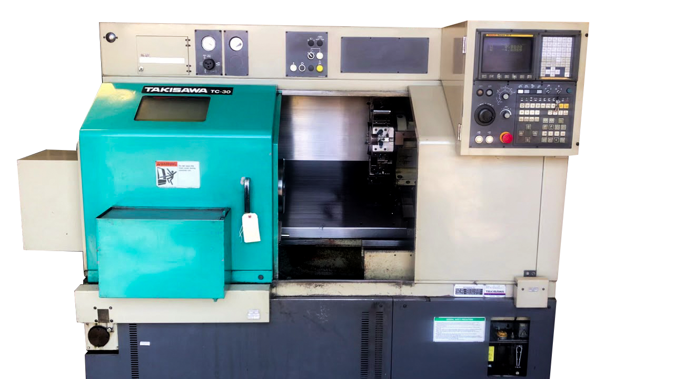
- TAKISAWA TC-30 CNC Turning Center (8 Nos.)

CNC Lathe with following specifications
- Length – 500mm
- Chuck Dia. – 250mm
- Maximum Turning Dia. – 300mm
- Spindle RPM : 1 - 4000,
- Power - 30 KW,
- Hydraulic Chuck and Hydraulic Tailstock.
- 10 station Hydraulic turret and servo turret .
- CNC System : Fanuc OT, Fanuc Oi-TF

Unit-I : Plot No. D-10, 27 Ft. Road, Opp. Mani Ki Tal, Dabua Colony, N.I.T. Faridabad-121001(HR.)
Unit-II : Plot No. 10, Gali No. 3 (West), Saroorpur Ind. Area, Faridabad-121001(HR.)
Mobile : 9212662771, 9971900484
E-mail :info@ranoliaengg.com website : www.ranoliaengg.com
RANOLIA ENGINEERING
(AN ISO 9001-2015 CERTIFIED COMPANY)
Spl. In : ALL KINDS OF CNC & VMC JOB WORKS

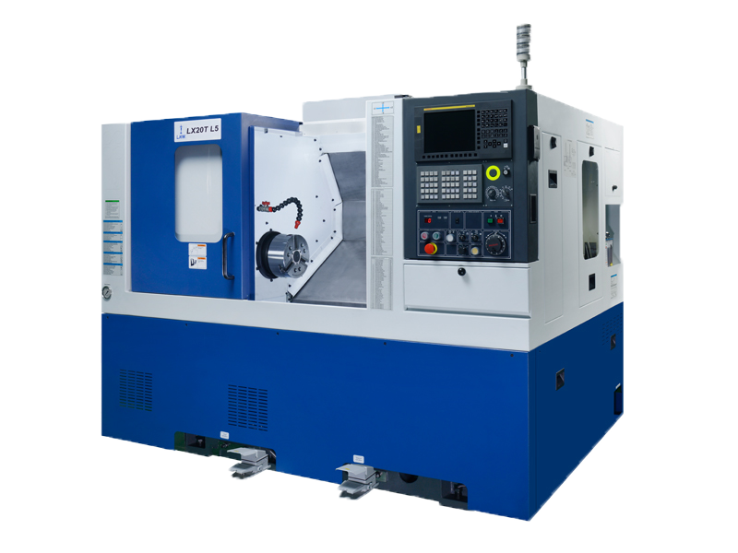
2).LMW LX20T L5CNC Turning Center (6Nos.)

CNC Lathe with following specifications
- Length – 500mm
- Chuck Dia. – 200mm
- Maximum Turning Dia. – 250mm
- Spindle RPM : 1 - 6000,
- Power - 20 KW,
- Hydraulic Chuck and Hydraulic Tailstock.
- 8 station Hydraulic turret and servo turret .
- CNC System : Fanuc OT, Fanuc Oi-TF

Unit-I : Plot No. D-10, 27 Ft. Road, Opp. Mani Ki Tal, Dabua Colony, N.I.T. Faridabad-121001(HR.)
Unit-II : Plot No. 10, Gali No. 3 (West), Saroorpur Ind. Area, Faridabad-121001(HR.)
Mobile : 9212662771, 9971900484
E-mail :info@ranoliaengg.com website : www.ranoliaengg.com
RANOLIA ENGINEERING
(AN ISO 9001-2015 CERTIFIED COMPANY)
Spl. In : ALL KINDS OF CNC & VMC JOB WORKS

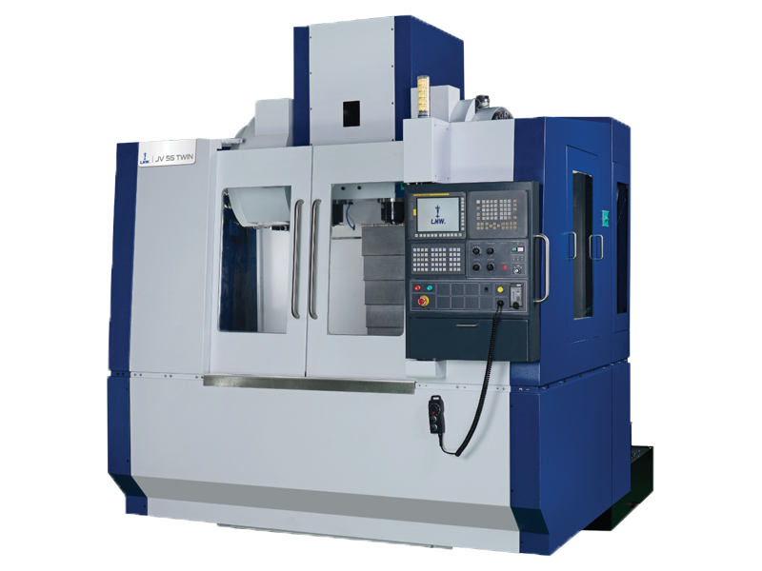
3).LMW JV Kraft VMC MILLING MACHINE (2 Nos.)

VMC Milling with following specifications
- Length – 500mm
- Maximum Turning Dia. – 250mm
- Height – 1000mm
- Spindle RPM : 1– 12000,
- Power – 20KW,
- CNC System – Fanuc OT, Fanuc Oi-TF

Unit-I : Plot No. D-10, 27 Ft. Road, Opp. Mani Ki Tal, Dabua Colony, N.I.T. Faridabad-121001(HR.)
Unit-II : Plot No. 10, Gali No. 3 (West), Saroorpur Ind. Area, Faridabad-121001(HR.)
Mobile : 9212662771, 9971900484
E-mail :info@ranoliaengg.com website : www.ranoliaengg.com
RANOLIA ENGINEERING
(AN ISO 9001-2015 CERTIFIED COMPANY)
Spl. In : ALL KINDS OF CNC & VMC JOB WORKS

4). NAKAMURA TC-30 CNC Turning Center (2 Nos.)
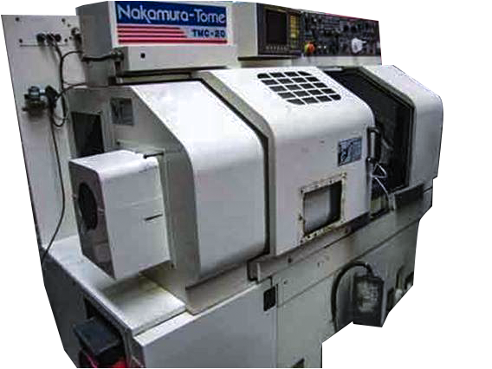

CNC Lathe with following specifications
- Length – 500mm
- Chuck Dia. – 250mm
- Maximum Turning Dia. – 300mm
- Spindle RPM : 1 - 6000,
- Power - 20 KW,
- Hydraulic Chuck and Hydraulic Tailstock.
- 08 station Hydraulic turret and servo turret .
- CNC System : Fanuc OT, Fanuc Oi-TF

Unit-I : Plot No. D-10, 27 Ft. Road, Opp. Mani Ki Tal, Dabua Colony, N.I.T. Faridabad-121001(HR.)
Unit-II : Plot No. 10, Gali No. 3 (West), Saroorpur Ind. Area, Faridabad-121001(HR.)
Mobile : 9212662771, 9971900484
E-mail :info@ranoliaengg.com website : www.ranoliaengg.com
RANOLIA ENGINEERING
(AN ISO 9001-2015 CERTIFIED COMPANY)
Spl. In : ALL KINDS OF CNC & VMC JOB WORKS

5). AUTOMATIC BAND SAW MACHINE (2 Nos.)

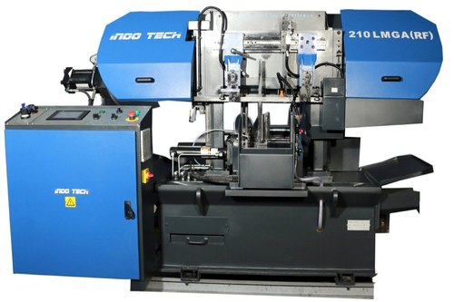

BAND SAW with following specifications
- Cutting Dia.. – 210mm
- Spindle RPM : 1 - 6000,
- Double Column Band saw machine 210 LMGA with Hydraulic blade tension, Mechanical length setting arrangements, and bundle cutting attachment features

Unit-I : Plot No. D-10, 27 Ft. Road, Opp. Mani Ki Tal, Dabua Colony, N.I.T. Faridabad-121001(HR.)
Unit-II : Plot No. 10, Gali No. 3 (West), Saroorpur Ind. Area, Faridabad-121001(HR.)
Mobile : 9212662771, 9971900484
E-mail :info@ranoliaengg.com website : www.ranoliaengg.com
RANOLIA ENGINEERING
(AN ISO 9001-2015 CERTIFIED COMPANY)
Spl. In : ALL KINDS OF CNC & VMC JOB WORKS

6). JYOTI DX200 A5CNC Turning Center (2 Nos.)
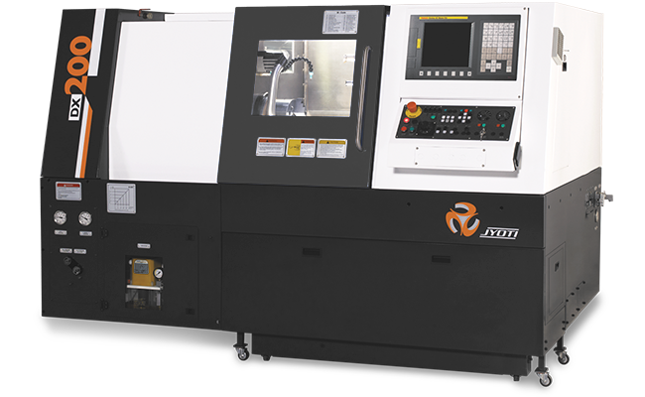

CNC Lathe with following specifications
- Length – 500mm
- Chuck Dia. – 250mm
- Maximum Turning Dia. – 300mm
- Spindle RPM : 1 - 4000,
- Power - 30 KW,
- Hydraulic Chuck and Hydraulic Tailstock.
- 10 station Hydraulic turret and servo turret .
CNC System : Fanuc OT, Fanuc Oi-TF

Unit-I : Plot No. D-10, 27 Ft. Road, Opp. Mani Ki Tal, Dabua Colony, N.I.T. Faridabad-121001(HR.)
Unit-II : Plot No. 10, Gali No. 3 (West), Saroorpur Ind. Area, Faridabad-121001(HR.)
Mobile : 9212662771, 9971900484
E-mail :info@ranoliaengg.com website : www.ranoliaengg.com
RANOLIA ENGINEERING
(AN ISO 9001-2015 CERTIFIED COMPANY)
Spl. In : ALL KINDS OF CNC & VMC JOB WORKS

7).DRILL MACHINES (5 Nos.)
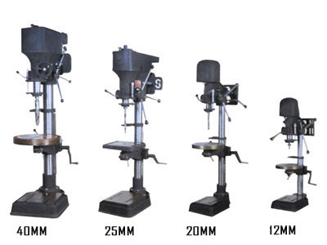

Drill machines with following specifications
Drilling Capacity in mild steel | 15 mm | 19 mm | 25 mm | 32 mm | 38 mm
Pillar Diameter | 58.50 mm | 74.50 mm | 90 mm | 114.50 mm | 114.50 mm
Spindle Nose to Table distance | 482 mm | 430 mm | 710 mm | 762 mm | 815 mm
Distance from spindle Centre to pillar surface (in mm) | 177 mm | 217 mm | 259 mm | 299 mm | 317 mm
Table Travel | 305 mm | 381 mm | 485 mm | 485 mm | 485 mm
Taper in Spindle | MT 2 | MT 2 | MT 3 | MT 4 | MT 4
Number of speed | 4 Speed | 8 Speed | 8 Speed | 8 Speed | 8 Speed
Spindle Trneel | 100 mm | 140 mm | 165 mm | 190 mm | 190 mm
Pillar length | 840 mm | 990 mm | 1450 mm | 1490 mm | 1510 mm
Overall Height with pulley grand | 1143 mm | 1295 mm | 1840 mm | 1880 mm | 1900 mm
V-Belt Section | A | A | B | B | B
Weight (approx.) | 60 Kg | 125 Kg | 180 Kg | 250 Kg | 300 Kg
Ram Diameter (MM) | 495 mm | 58 mm | 64 mm | 74 mm | 74 mm
Motor 1440 RPM 3 Phase  440 volts | 0.5 H .P. | 1 H .P. | 1 H .P. | 1.5 H .P.  960 RPM | 2 H .P.  960 RPM

Unit-I : Plot No. D-10, 27 Ft. Road, Opp. Mani Ki Tal, Dabua Colony, N.I.T. Faridabad-121001(HR.)
Unit-II : Plot No. 10, Gali No. 3 (West), Saroorpur Ind. Area, Faridabad-121001(HR.)
Mobile : 9212662771, 9971900484
E-mail :info@ranoliaengg.com website : www.ranoliaengg.com
RANOLIA ENGINEERING
(AN ISO 9001-2015 CERTIFIED COMPANY)
Spl. In : ALL KINDS OF CNC & VMC JOB WORKS

8).Lathe/Turning Machine : (Four)

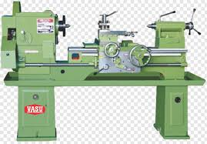

Lathe with following specifications :

- Maximum Turning Dia. : 450-800 mm.
- Maximum Distance Between Centers : 1500-3000 mm.
- Spindle RPM : 20- 1400,
- Power - 3 KW. Manual Chuck.
- System : Gear Head.

Unit-I : Plot No. D-10, 27 Ft. Road, Opp. Mani Ki Tal, Dabua Colony, N.I.T. Faridabad-121001(HR.)
Unit-II : Plot No. 10, Gali No. 3 (West), Saroorpur Ind. Area, Faridabad-121001(HR.)
Mobile : 9212662771, 9971900484
E-mail :info@ranoliaengg.com website : www.ranoliaengg.com
RANOLIA ENGINEERING
(AN ISO 9001-2015 CERTIFIED COMPANY)
Spl. In : ALL KINDS OF CNC & VMC JOB WORKS

9) MIG Welding Machine 600 Amp. (Two)

10) Hand Drill Machine (Four)

11) Hand Grinder (Five)

12) Bench Grinder (Two)

13) Buffing Machine (Two)

14) Overhead Crane 5 Ton (One)

15) D.G. Set 100 kVA Ashok Leyland (One)

Unit-I : Plot No. D-10, 27 Ft. Road, Opp. Mani Ki Tal, Dabua Colony, N.I.T. Faridabad-121001(HR.)
Unit-II : Plot No. 10, Gali No. 3 (West), Saroorpur Ind. Area, Faridabad-121001(HR.)
Mobile : 9212662771, 9971900484
E-mail :info@ranoliaengg.com website : www.ranoliaengg.com

MSME

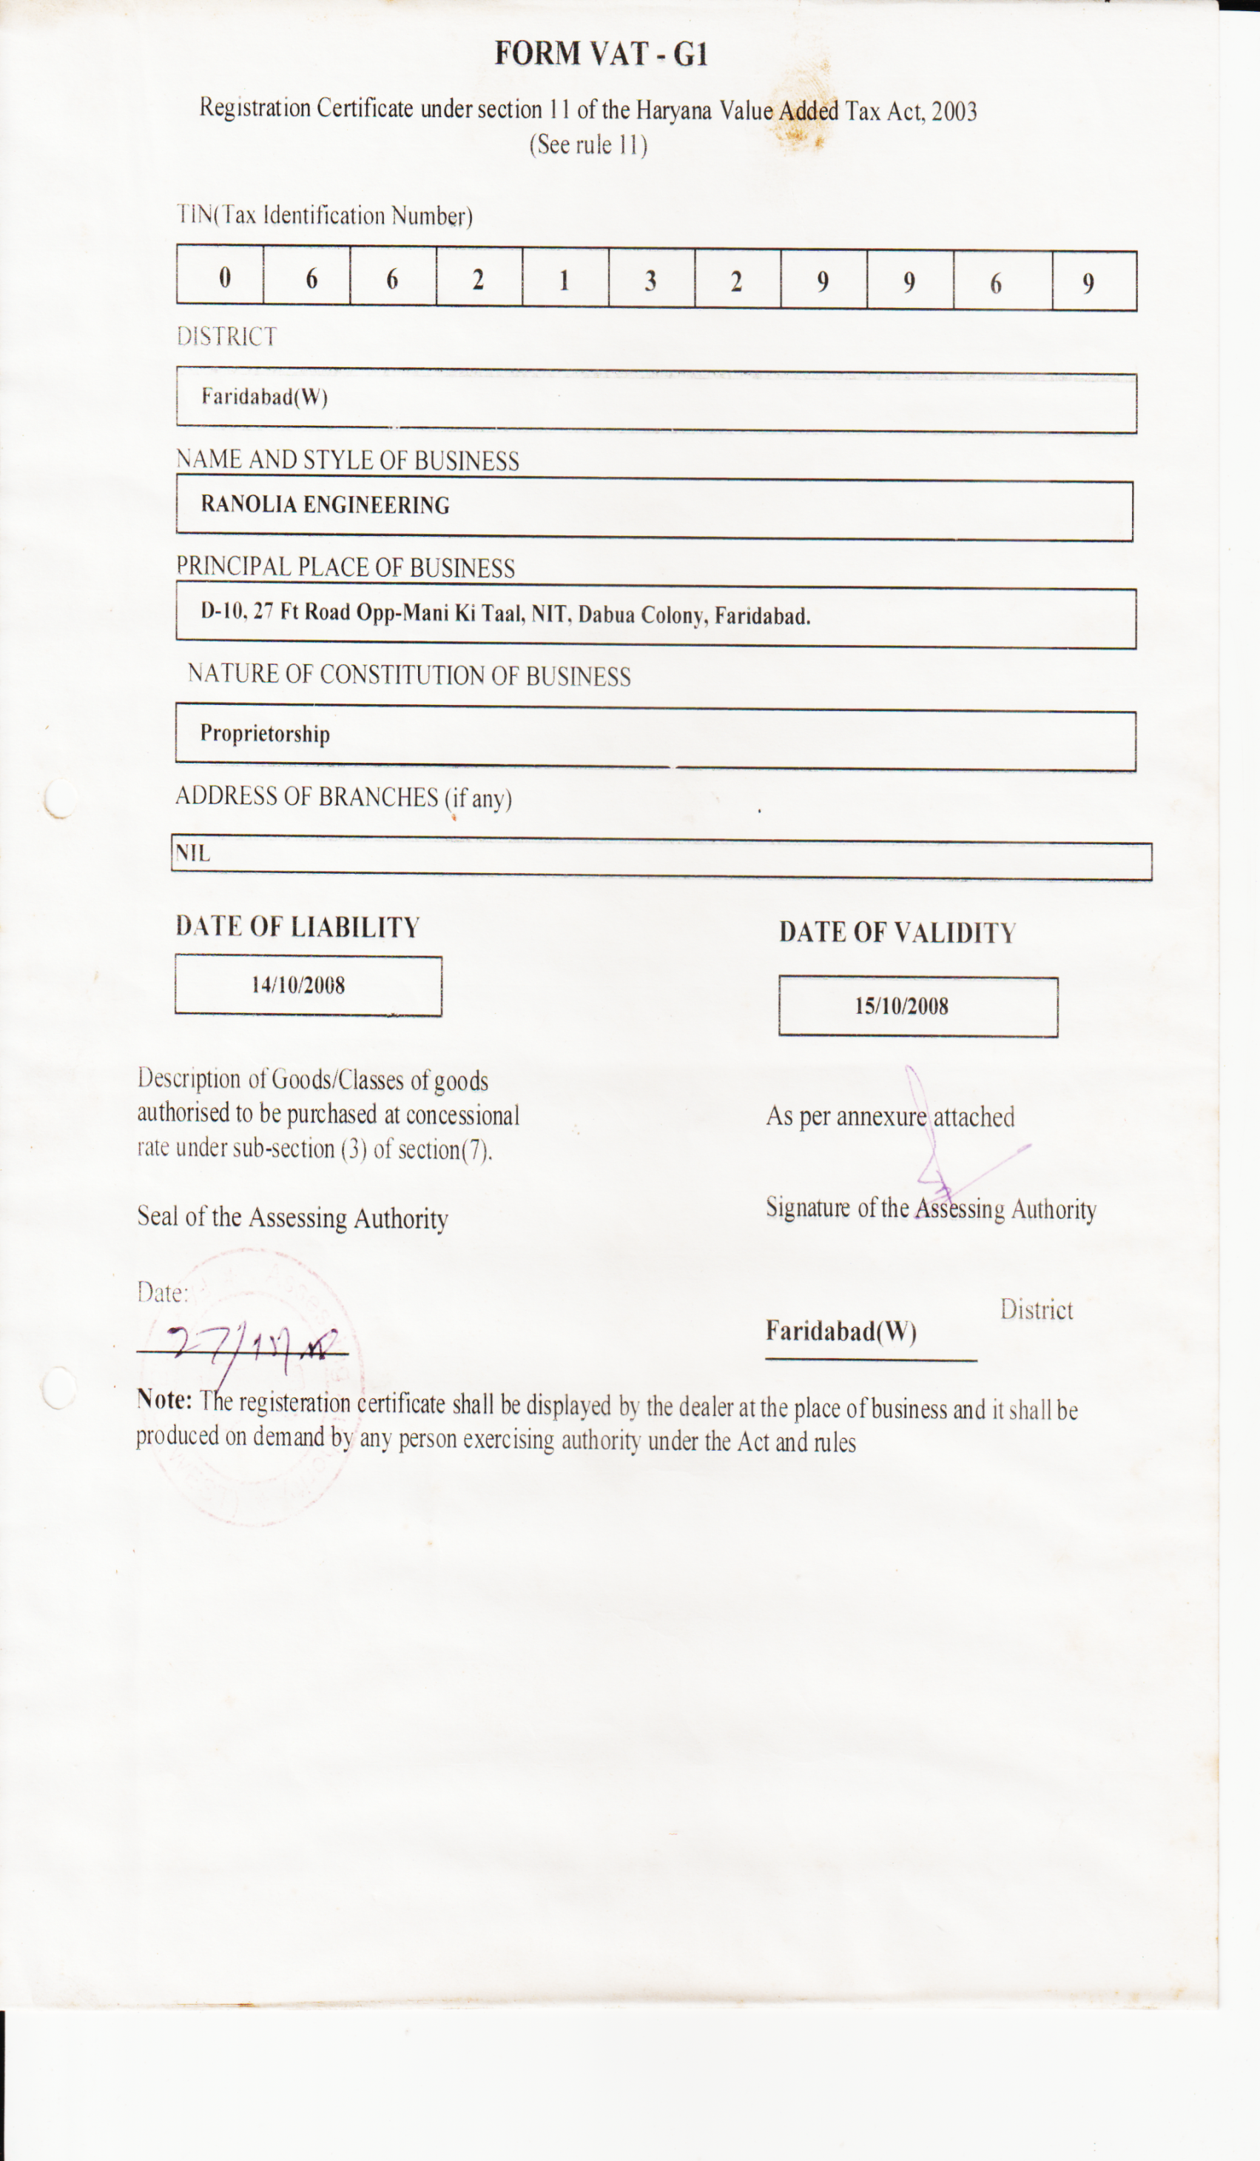

ISO
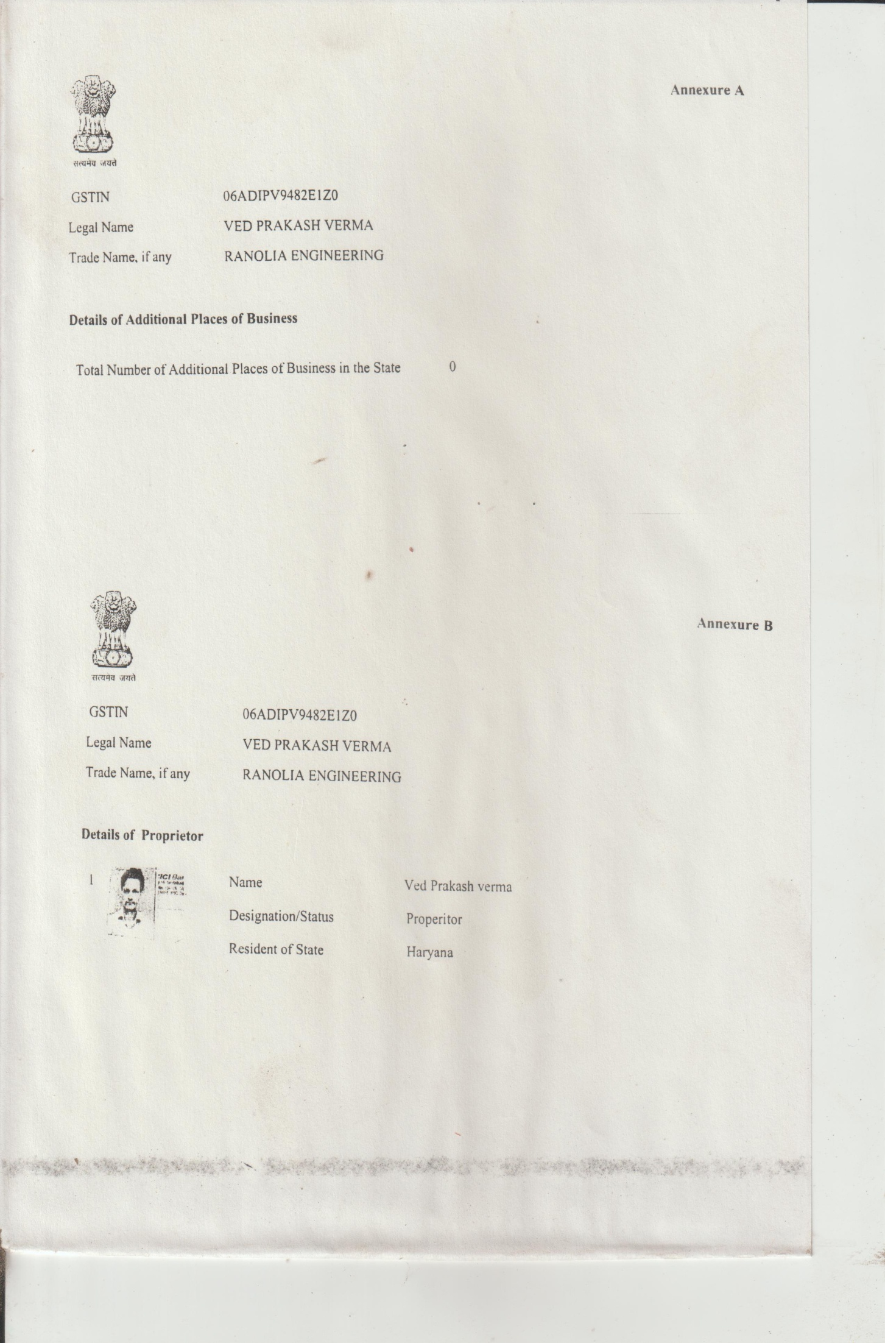

SADHU GEAR LIMITED

INSTRUMENT LIST

SALES TAX REGISTRATION

COMPONENT LIST

